Иляева Эдита Ис31к(https://github.com/ilae-web?tab=repositories)
Задача 1 — TinyHorn
python
class TinyHorn:
def play(self):
print("toot")
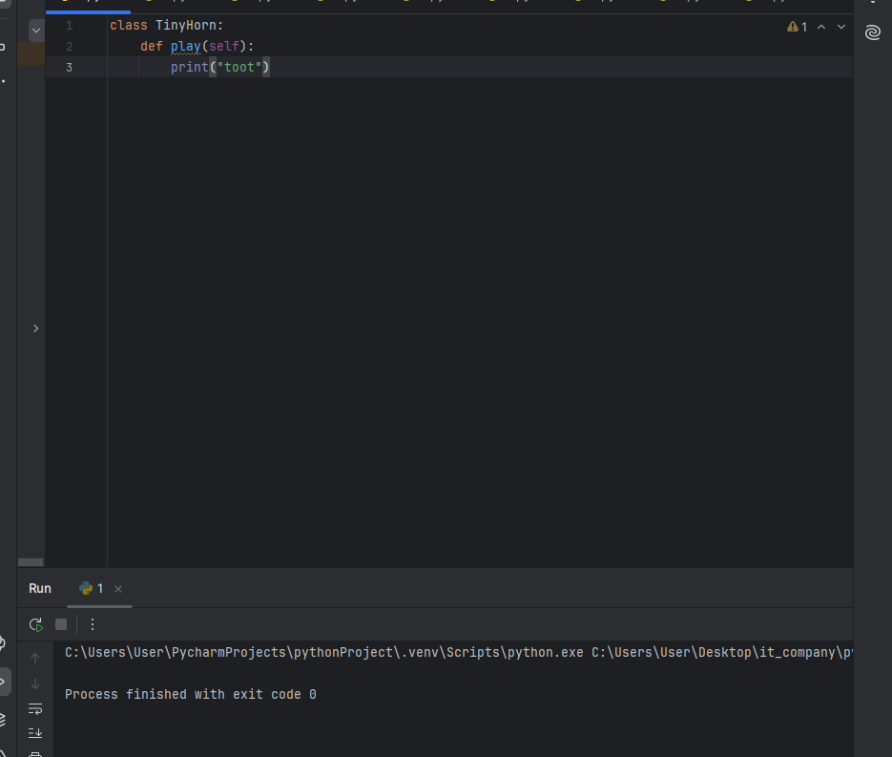

Задача 2 — CounterButton
python
class CounterButton:
def __init__(self):
self._count = 0

def press(self):
self._count += 1

def count(self):
return self._count

def reset(self):
self._count = 0
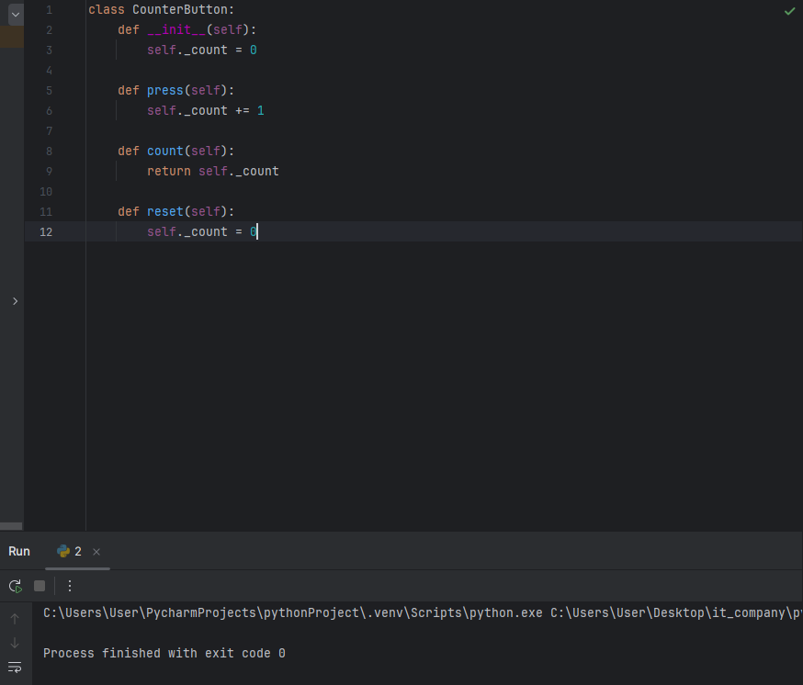
Задача 3 — SeeSaw
python
class SeeSaw:
def __init__(self):
self.left_weight = 0
self.right_weight = 0
def add_right(self, weight):
self.right_weight += weight
def add_left(self, weight):
self.left_weight += weight
def balance(self):
if self.left_weight > self.right_weight:
return 'L'
elif self.right_weight > self.left_weight:
return 'R'
else:
return '='
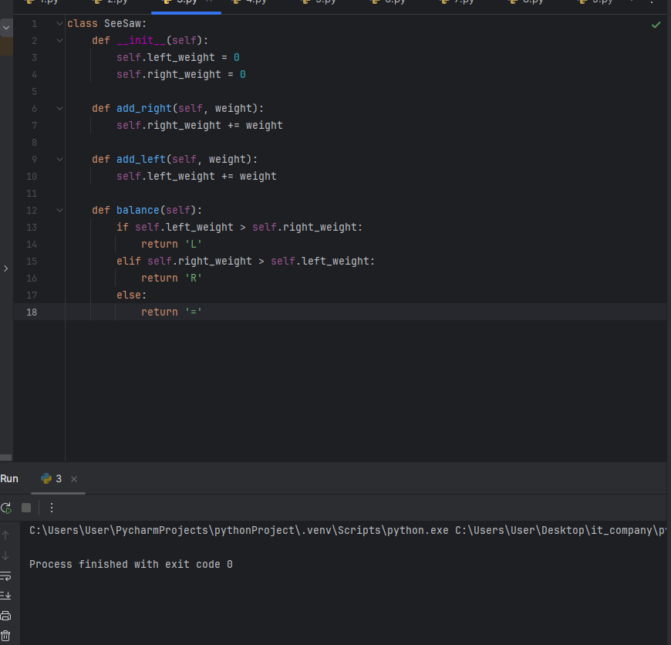
Задача 4 — NumberDivider
python
class NumberDivider:
def __init__(self):
self.numbers = []

def add_number(self, n):
self.numbers.append(n)

def divisible(self):
return [x for x in self.numbers if x % 3 == 0]

def not_divisible(self):
return [x for x in self.numbers if x % 3 != 0]
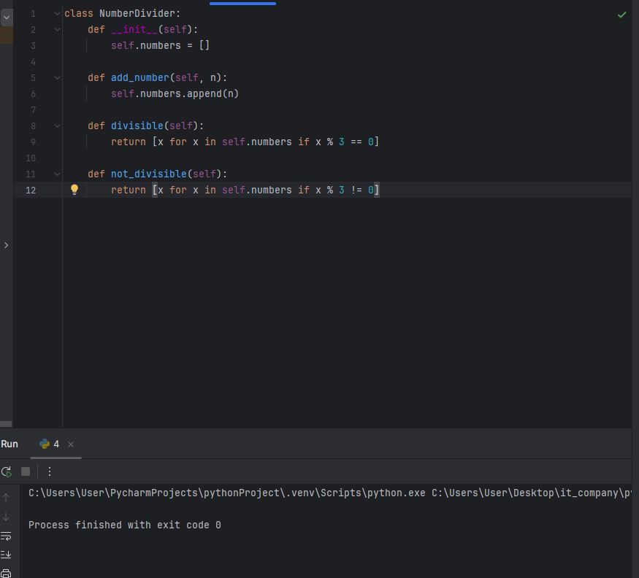
Задача 5 — FlipFlopBell
python
class FlipFlopBell:
def __init__(self):
self.counter = 0

def ring(self):
if self.counter % 2 == 0:
print("flip")
else:
print("flop")
self.counter += 1
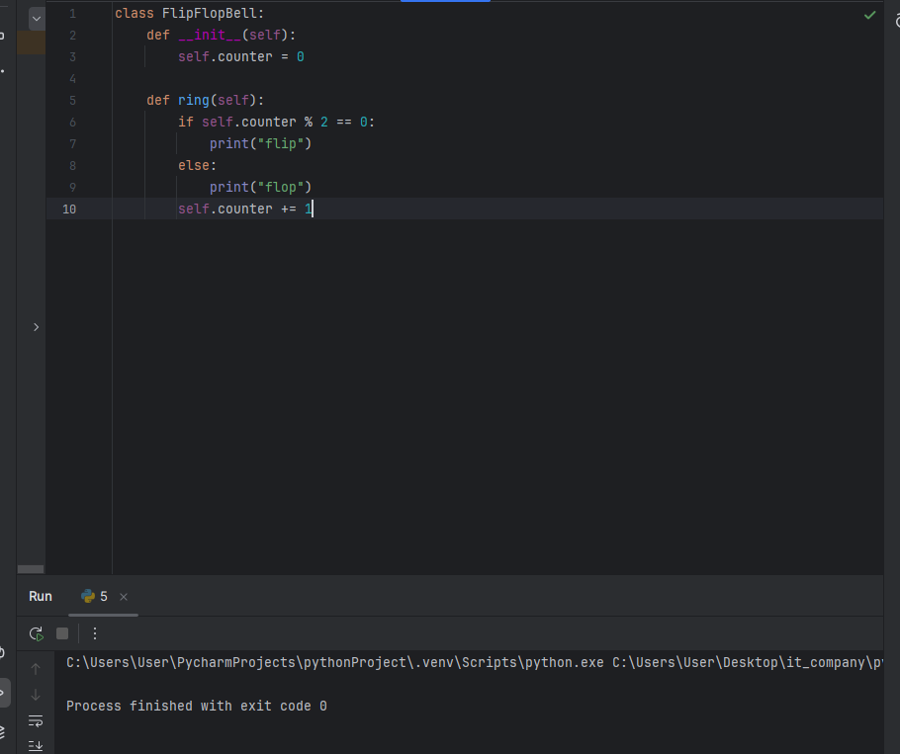
Задача 6 — MinMaxNumberFinder
python
class MinMaxNumberFinder:
def __init__(self):
self.numbers = []
def add_number(self, n):
self.numbers.append(n)
def min_numbers(self):
if not self.numbers:
return []
min_val = min(self.numbers)
return [x for x in self.numbers if x == min_val]
def max_numbers(self):
if not self.numbers:
return []
max_val = max(self.numbers)
return sorted(set([x for x in self.numbers if x == max_val]))
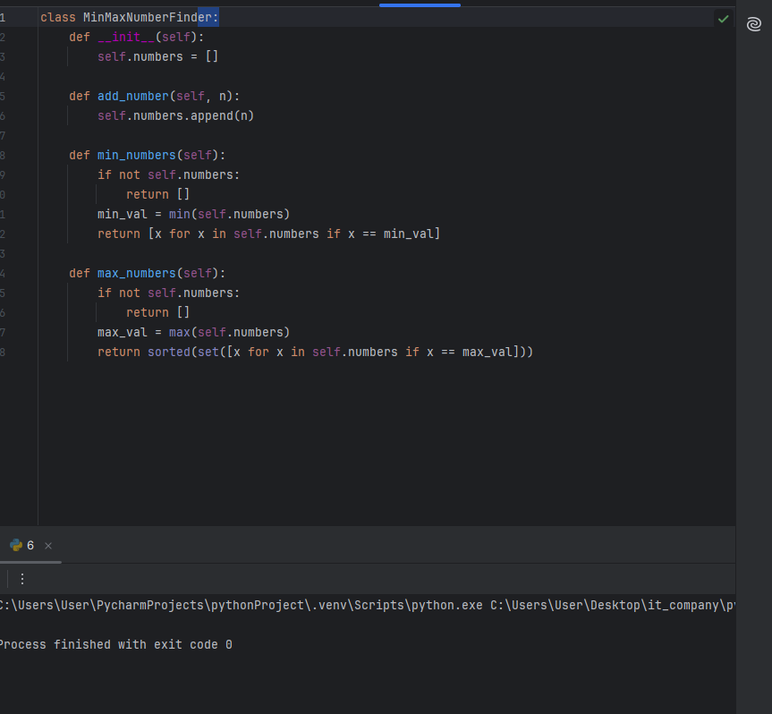
Задача 7 — BoundingBox2D
python
class BoundingBox2D:
def __init__(self):
self.points = []
def add_point(self, x, y):
self.points.append((x, y))
def left_x(self):
return min(p[0] for p in self.points)
def right_x(self):
return max(p[0] for p in self.points)
def bottom_y(self):
return min(p[1] for p in self.points)

def top_y(self):
return max(p[1] for p in self.points)
def width(self):
return self.right_x() - self.left_x()
def height(self):
return self.top_y() - self.bottom_y()
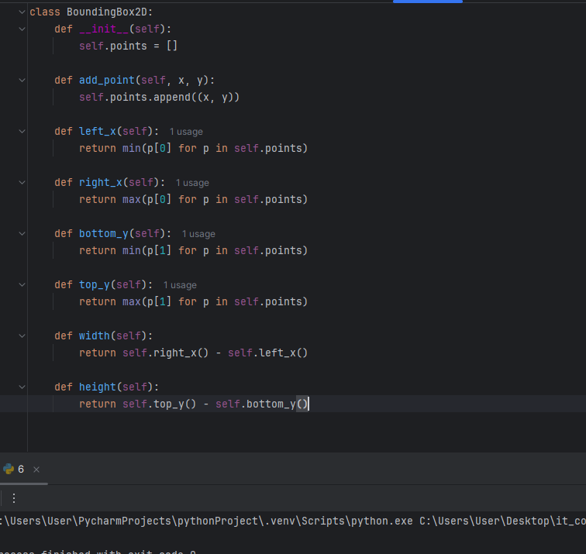
Задача 8 — WordCaseSeparator
python
class WordCaseSeparator:
def __init__(self):
self.words = []

def add_word(self, word):
self.words.append(word)

def upper_case_words(self):
return [w for w in self.words if w and w[0].isupper()]

def lower_case_words(self):
return [w for w in self.words if w and w[0].islower()]
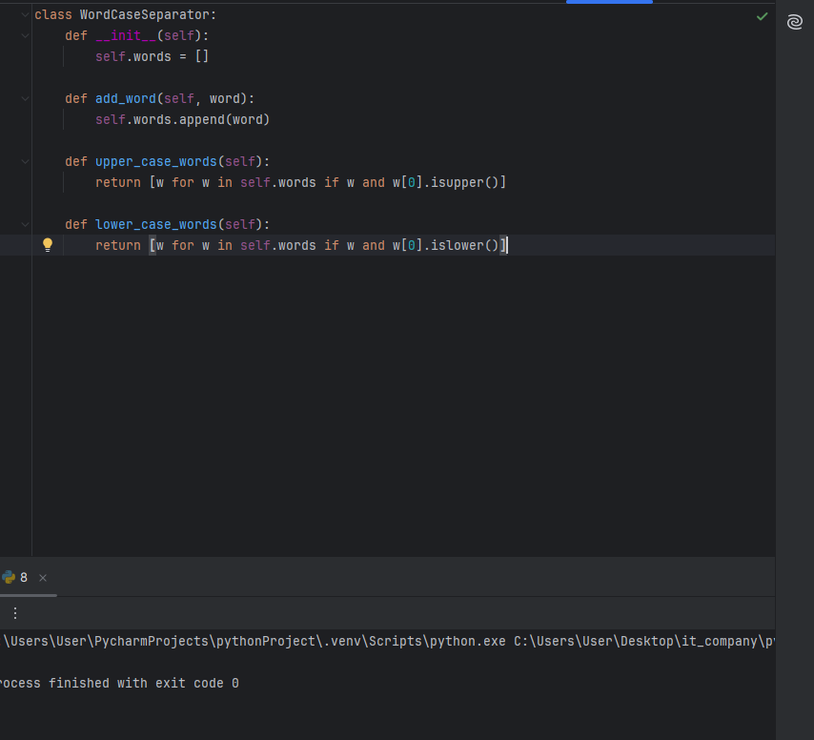
Задача 9 — EvenOddSumTracker
python
class EvenOddSumTracker:
def __init__(self):
self.even_total = 0
self.odd_total = 0

def add_number(self, n):
if n % 2 == 0:
self.even_total += n
else:
self.odd_total += n

def even_sum(self):
return self.even_total

def odd_sum(self):
return self.odd_total
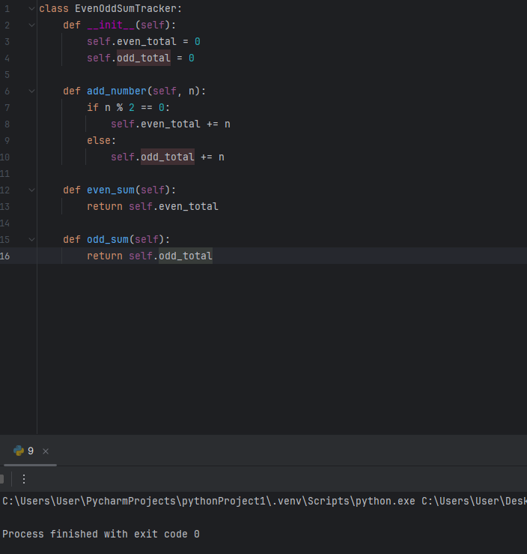
Задача 10 — AlternatingCounter
python
class AlternatingCounter:
def __init__(self):
self.a = 0
self.b = 0
self.next_is_a = True
def count(self):
if self.next_is_a:
self.a += 1
else:
self.b += 1
self.next_is_a = not self.next_is_a
return (self.a, self.b)
def reset(self):
self.a = 0
self.b = 0
self.next_is_a = True
